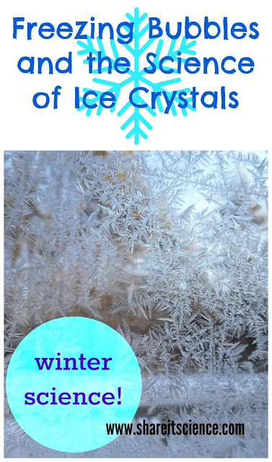

The past few weeks have been very chilly here in New England, as they have elsewhere. We're desperately looking for a way to tamp down our spring fever. The other night when it was well below freezing we decided to go outside and freeze some bubbles.
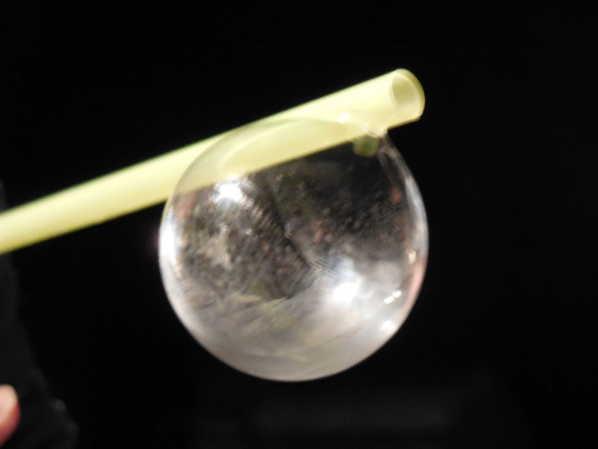
A bubble beginning to freeze. You can just see the fern-like frost beginning to form. ©SBF
Freezing bubbles is a simple activity with pretty awe-inspiring results. We made some bubble solution (1 Tablespoon dish soap, 1 Tablespoon corn syrup, 9 Tablespoons water) and used drinking straws as our wands. Smaller bubbles still attached to the wand work best, too big and they break or float away. (For more ideas and tips on freezing bubbles and other bubble activities, check out the links in the resources section below.)
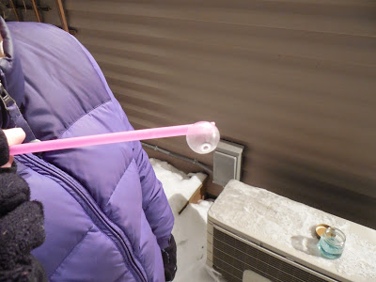
The frozen bubble- awesome! ©RF
As our bubbles froze beautiful fern-like ice crystals form around the surface like a frosted window.

